Colour in and label the five rings.  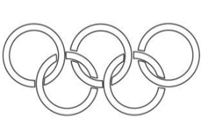 | Learn About the Olympics with Ozzie  Watch the video. Using chalk, write or draw some facts you remember on your driveway/path (with your parents' permission).  https://youtu.be/Uk0tPbek-oc | Have a go at drawing the Olympic Mascot.  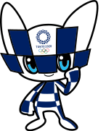 | Create your own Mascot!  Use the Internet to research some of the previous Olympic Mascots. | Write down five sports that are played at the Paralympics. Draw a picture beside each.  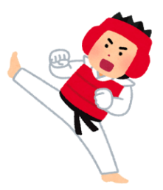
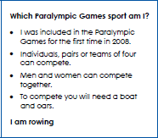 | Have a go at writing your own ‘What sport am I?’  (See the example to the left). | Lizzie (below) is the Australian Paralympic Team Mascot.  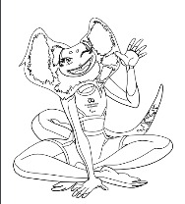  Create your own Australian Paralympic Team mascot. | My favourite sport  What is your favourite sport and why? Show us a photo or video of you doing that sport. Could you be an Olympian and why do you think that? | Village Art  How do artists communicate through their artwork?  Your task is to decorate the walls at the athlete’s village in Japan!  What sort of images and words would encourage the athletes to perform at their best?
Draw a flag of your choice. | Flag Jigsaw  Print out the flags of some countries taking part in the Tokyo Olympics. Cut each of them up in jigsaw pieces, shuffle them around and see if you can make the flags | Olympic victory dance  Come up with your own Olympic victory dance- what song would you do your dance to and why? | Join in the Quick Fun Olympics Workout  Join Chris and his young son Alex for a fun 6 minute "Olympics" workout! These simple exercises are based on Olympic sports like running, cycling, horse riding,  https://youtu.be/cwo9mpFA5fg | Design some new Olympic/Paralympic medals.  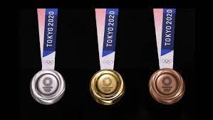
Write an acrostic poem about the Paralympics.  P  A  R  A  L  M  P  I  C  S | 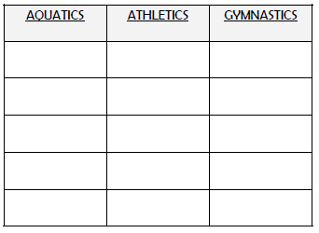  Can you write some Paralympic sports under these headings | Test your acting skills  Pretend you have just won an Olympic gold medal. Video how you would react after realising that you have won the gold medal and how you would walk up to receive the medal. | History of the Olympic Games  Watch the video  https://youtu.be/xBsRx4wN_v4  How were the early games different or the same to now?  What are some facts that you found interesting?  Present your ideas in any form you like. | Create your own Olympic torch from items found around the home.  