Sounds-Write Activities – Week 8 (Extended Code) (/ee/)
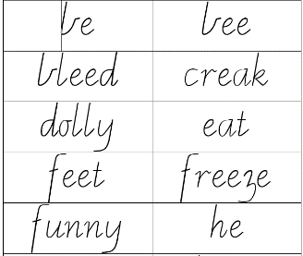

Activities using the word cards Cut out the word cards neatly and when not in use, store them in snap lock bag.
- Reading (5 – 10 minutes)
  - Put the cards face down on the table. Turn over each card one at a time. Practice ‘saying the sounds’ and ‘reading the word’ (even if the word is known). Ensure that the children do not over sound eg: saying ‘wuh’ instead of ‘woo’, ‘yuh’ instead of ‘yee’.
  - Repeat the task above. This time sort the word cards into columns of words that share the same way of spelling /ee/ as shown below:
e | ea | ee | y
be  he  she | creak  eat  Jean  meal  please  read  stream  wheat  seat | bee  bleed  feet  freeze  keep  meet  need  squeeze  three  tree | dolly  funny  messy  tummy
- Writing (5 – 10 minutes)
  - Spelling – Select 6 words to work with. Firstly, ‘say the sounds and read the word’, looking closely at how the word is spelt. Then turn the word over and “say the sounds and write the word”. Turn the card over again and check the word. Tick if correct. If not, write the word again using the same ‘look, say, cover, write, check’ process. Children should continue with this task until the selected words are written correctly.
  - This activity follows on from Reading task b (above). After sorting the words into columns of same spelling of /ee/ write the words into the work book making sure to put a ‘heading’ at the top of each column. For example:. (See example above under 1b).
- Other Activities:
  - Play ‘memory’ with a partner. Put all of the cards face down on the table. Take turns to turn over two cards. If the cards both have the same spelling of /ee/ keep the cards. Keep playing until all possible matches are made. There may be cards leftover. The child with the most matching pairs ‘wins’.
  - Challenge: Can you read all the word cards correctly in one minute?
  - Silly sentences - randomly select four cards. Can you put all 4 words into a sentence? The sentence can be spoken or written.

