ART

Week 4 PREP/1/2
Directed Drawing of a Chameleon

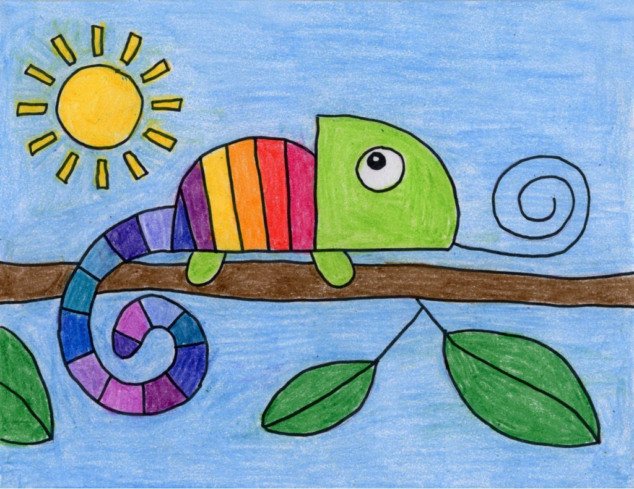

This week you will need help from an adult with each step. They can draw one with you or you may have a sibling in Prep/One or Two that you can complete the drawing at the same time with. Remember to hold on to your artwork or email me a picture at courtneyd@woodfordps.vic.edu.au

- Draw a quarter of a circle.
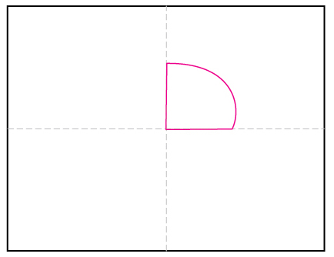
- Draw a simple body behind.
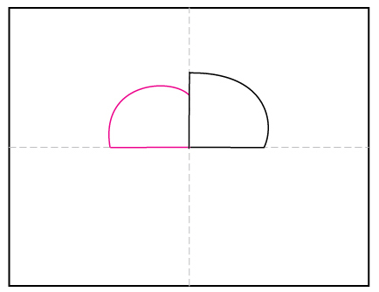
- Draw two legs.
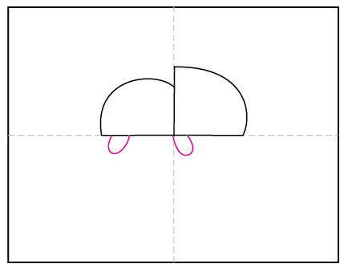
- Draw a curly tail.
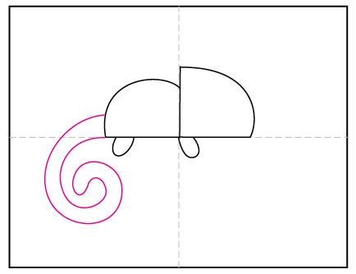

- Add an eye and curly tongue.
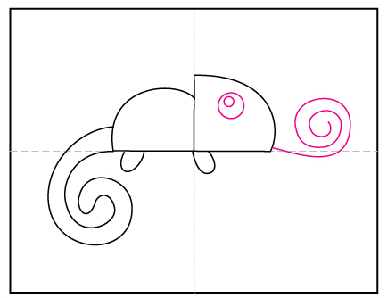
- Add strips to body and tail.
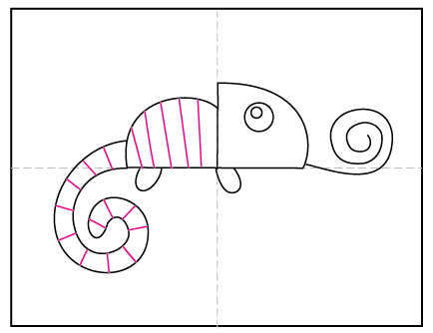
- Draw a branch and leaves below.
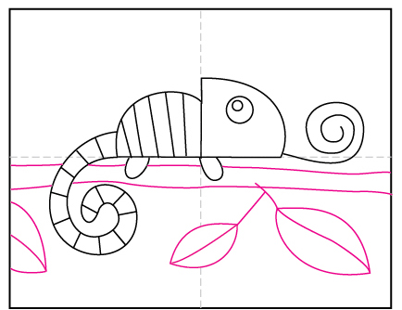

- Add a sun in the background.
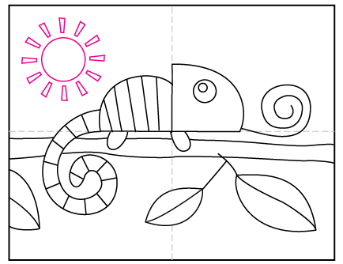
- Trace with a black texta and colour in.
